**WEB APPLICATION DEVELOPMENT LAB**

**02-01-2025**

Sai Ganesh Eswaraprasad

HU22CSEN0100287

Webpage where JavaScript is used to validate a form

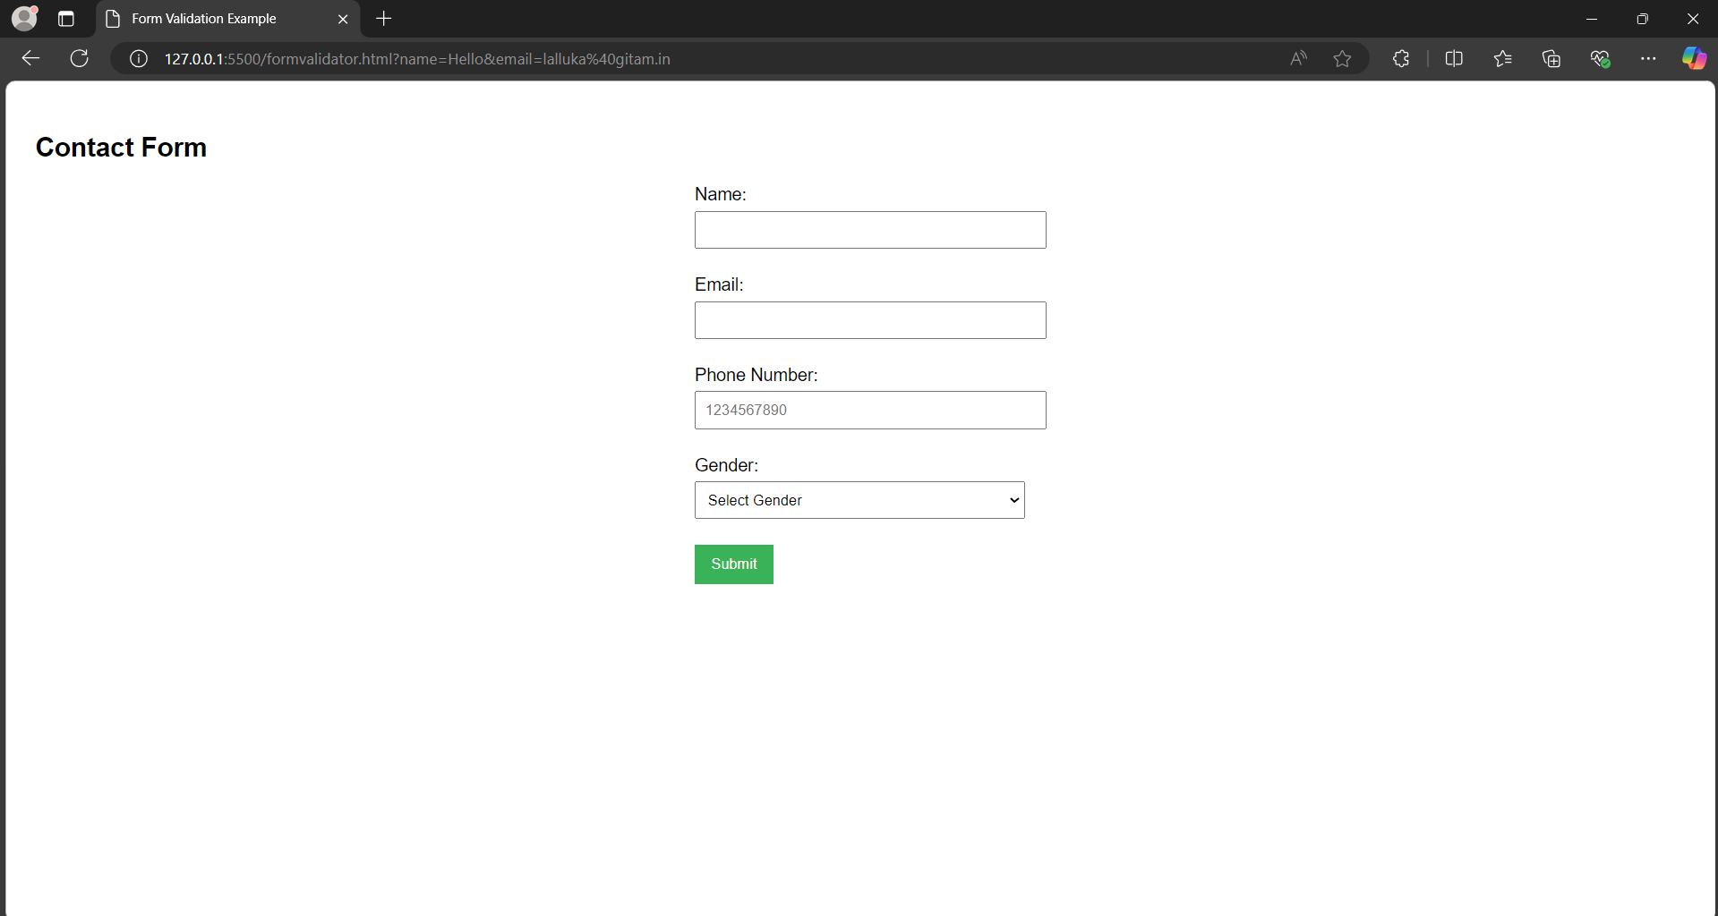

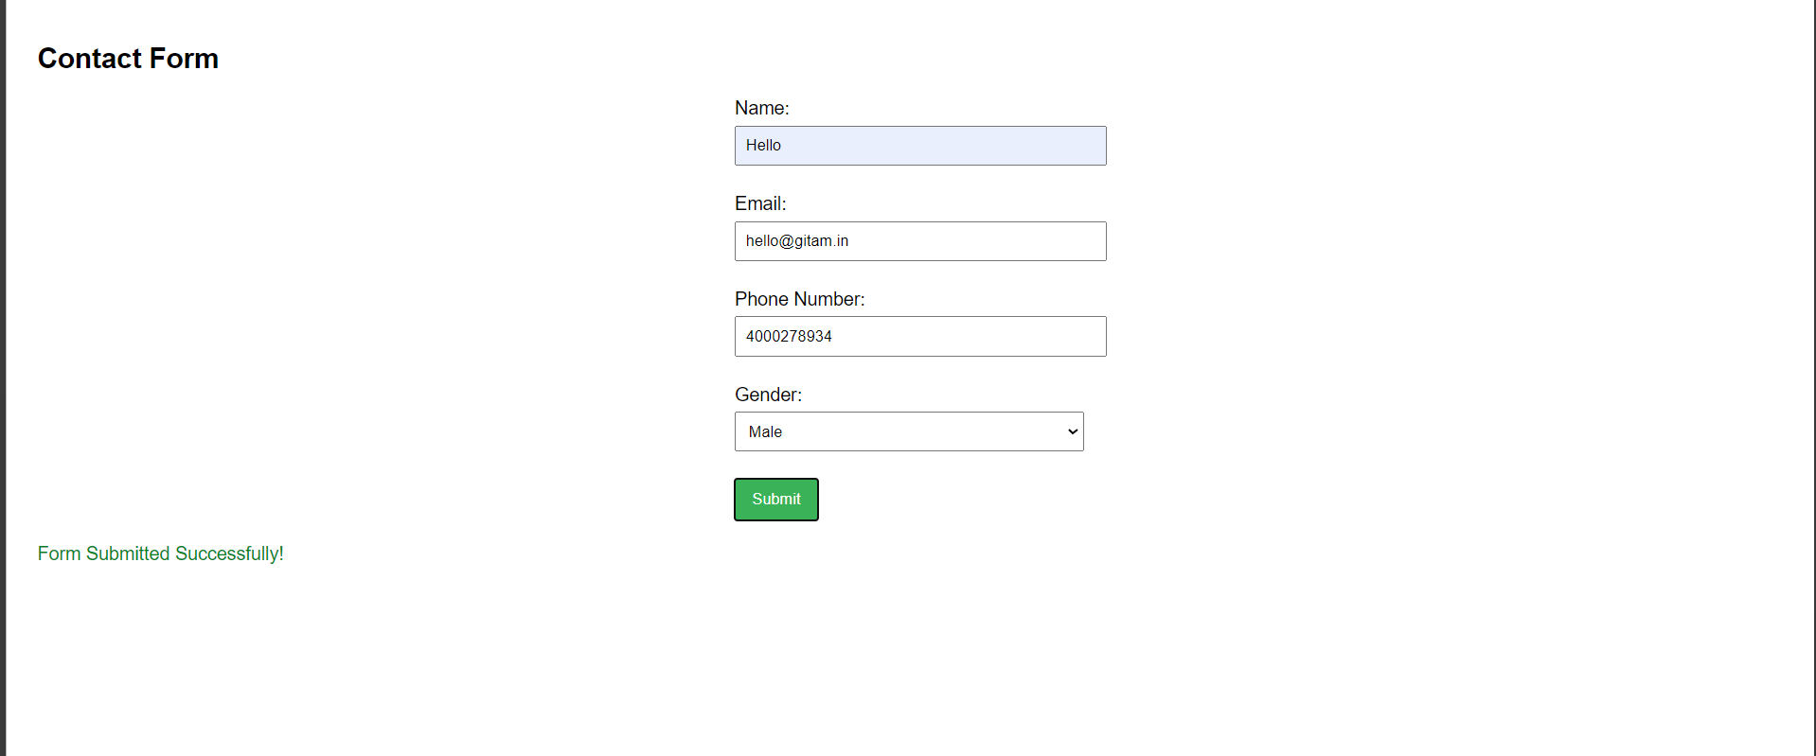

Errors:

   

CODE:

<!DOCTYPE html>

<html lang="en">

<head>

    <meta charset="UTF-8">

    <meta name="viewport" content="width=device-width, initial-scale=1.0">

    <title>Form Validation Example</title>

    <style>

        body {

            font-family: Arial, sans-serif;

            padding: 20px;

        }

        form {

            max-width: 300px;

            margin: auto;

        }

        input[type="text"], input[type="email"], input[type="tel"], select {

            width: 100%;

            padding: 8px;

            margin: 5px 0;

        }

        input[type="submit"] {

            padding: 10px 15px;

            background-color: #4CAF50;

            color: white;

            border: none;

            cursor: pointer;

        }

        input[type="submit"]:hover {

            background-color: #45a049;

        }

        #error-message {

            color: red;

            margin-top: 20px;

        }

        #success-message {

            color: green;

            margin-top: 20px;

        }

    </style>

</head>

<body>

    <h2>Contact Form</h2>

    <form id="contactForm" onsubmit="return validateForm()">

        <label for="name">Name:</label><br>

        <input type="text" id="name" name="name"><br><br>

        <label for="email">Email:</label><br>

        <input type="email" id="email" name="email"><br><br>

        <label for="phone">Phone Number:</label><br>

        <input type="tel" id="phone" name="phone" placeholder="1234567890"><br><br>

        <label for="gender">Gender:</label><br>

        <select id="gender" name="gender">

            <option value="">Select Gender</option>

            <option value="Male">Male</option>

            <option value="Female">Female</option>

            <option value="Other">Other</option>

        </select><br><br>

        <input type="submit" value="Submit">

    </form>

    <div id="error-message"></div>

    <div id="success-message"></div>

    <script>

        function validateForm() {

            let name = document.getElementById("name").value;

            let email = document.getElementById("email").value;

            let phone = document.getElementById("phone").value;

            let gender = document.getElementById("gender").value;

            let errorMessage = document.getElementById("error-message");

            let successMessage = document.getElementById("success-message");

            errorMessage.innerHTML = "";

            successMessage.innerHTML = "";

            if (name === "" || email === "" || phone === "" || gender === "") {

                errorMessage.innerHTML = "All fields (Name, Email, Phone, Gender) are required.";

                return false;

            }

            let emailPattern = /^[a-zA-Z0-9._-]+@[a-zA-Z0-9.-]+\.[a-zA-Z]{2,6}$/;

            if (!email.match(emailPattern)) {

                errorMessage.innerHTML = "Please enter a valid email address.";

                return false;

            }

            let phonePattern = /^\d{3}\d{3}\d{4}$/;

            if (!phone.match(phonePattern)) {

                errorMessage.innerHTML = "Please enter a valid phone number (e.g., 123-456-7890).";

                return false;

            }

            successMessage.innerHTML = "Form Submitted Successfully!";

            return false;

        }

    </script>

</body>

</html>